Recommended Laptops for Data Science and Machine Learning Projects

The objective is to acquire high-performance laptops capable of supporting secure, fully local artificial intelligence, machine learning, and data science workloads within the institution. These systems will enable large-scale tax data analytics and anomaly detection, advanced natural language processing tasks such as large language model (LLM) fine-tuning and inference, and computer vision applications including OCR, electronic billing machine (EBM) invoice analysis, and fraud detection. They will also support multimodal AI systems that incorporate retrieval-augmented generation (RAG) over complex document collections containing structured schemas, diagrams, and tables, requiring powerful compute resources to effectively run LLMs and multimodal models for building intelligent chatbots and other AI-driven institutional tools. By ensuring all processing is conducted locally, this approach guarantees full data privacy, eliminates reliance on external cloud GPU services, and provides a scalable foundation for multiple teams and future expansion of AI capabilities.

- MacBook Pro 16-inch (M5 Max)
Why: With up to 128GB of unified memory, this laptop is capable of running very large models (e.g., 70B parameters) locally. The M5 Max features a 16-core Neural Engine and a GPU with enhanced shader cores that significantly speed up transformer model training and image generation.

Technical Specifications

Criteria | Values | Image
Year introduced | 2026 | 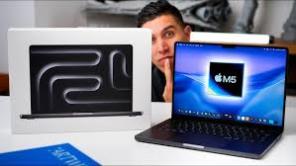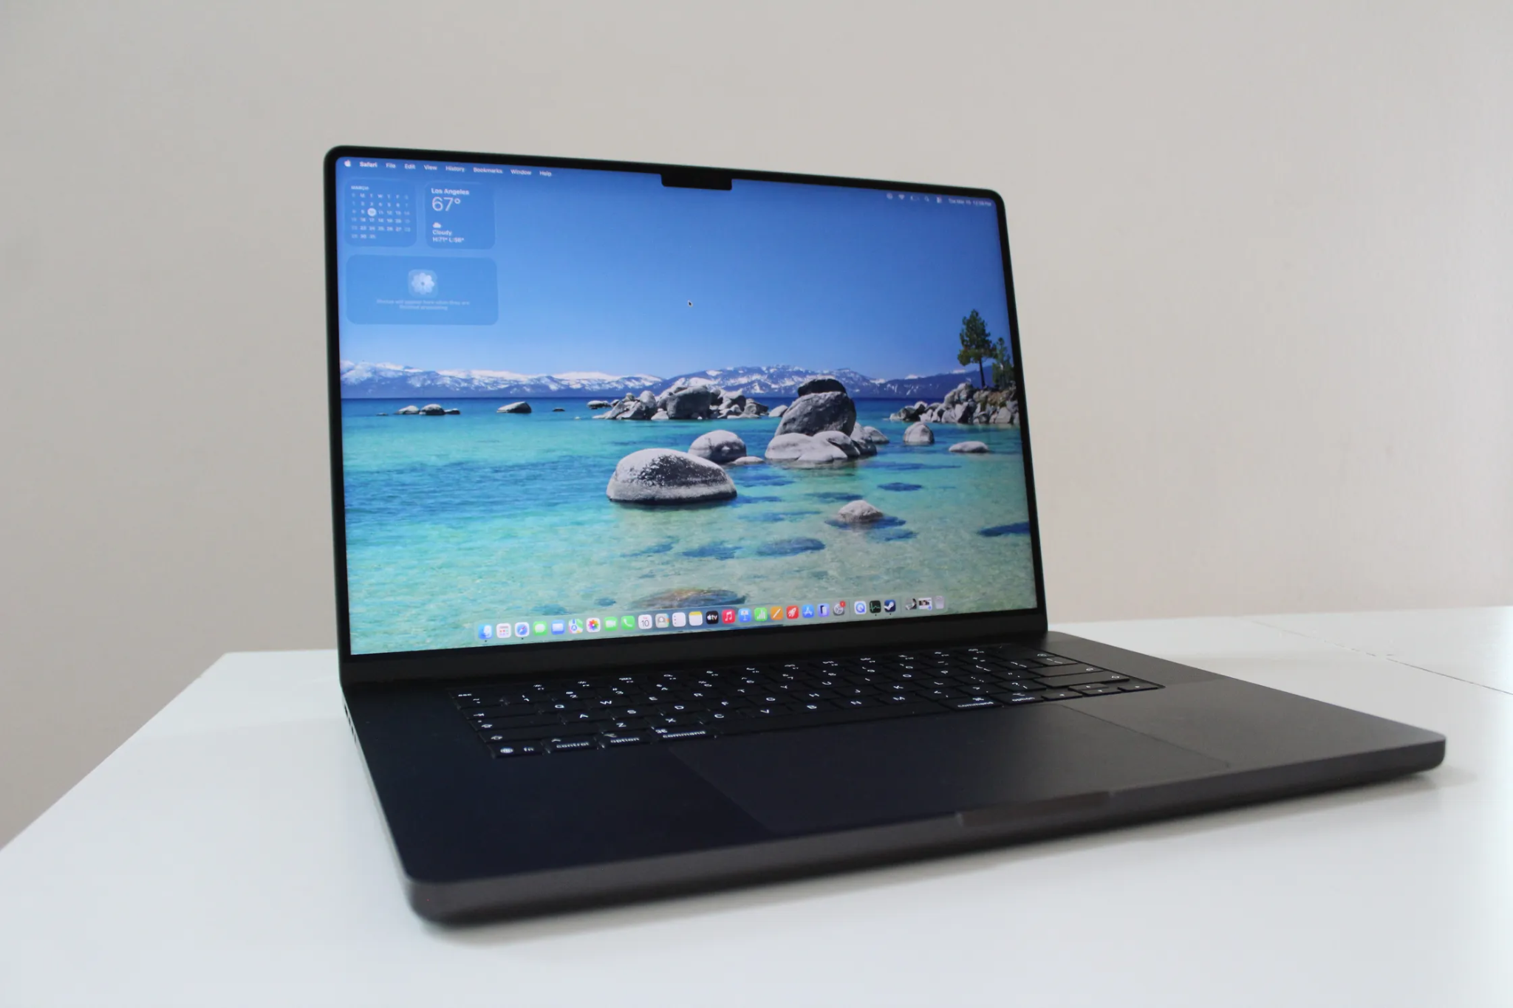
Chip | Apple M5 Pro chip  18-core CPU with 6 super cores and 12 performance cores.  20-core GPU
Neural Accelerators | Hardware-accelerated ray tracing  16-core Neural Engine  307GB/s memory bandwidth  Configurable to: M5 Max with 18-core CPU and 32-core GPU (460GB/s memory bandwidth) or M5 Max with 18-core CPU and 40-core GPU (614GB/s memory bandwidth)
Memory | 24GB unified memory  Configurable to: 36GB (M5 Max with 32-core GPU) or 48GB (M5 Pro or M5 Max with 40-core GPU) or 64GB (M5 Pro with 20-core GPU | 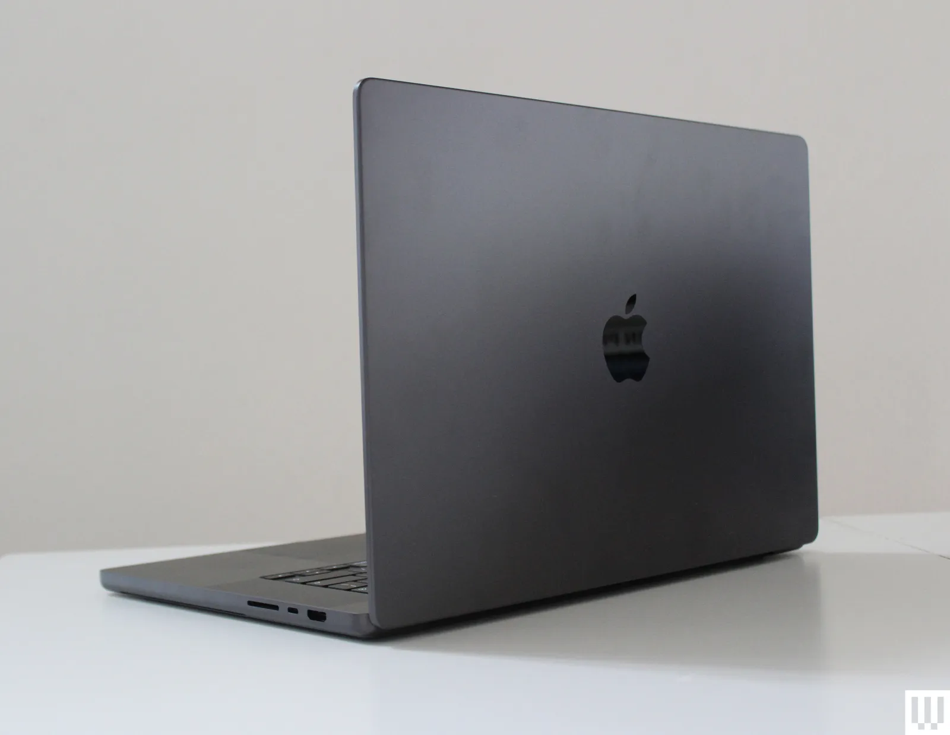
Storage | 1TB SSD  Configurable to: 2TB or 4TB
Display | Liquid Retina XDR display  16.2-inch (diagonal) Liquid Retina XDR display; 3456-by-2234 native resolution at 254 pixels per inch
Battery and Power16  M5 Pro | Up to 24 hours video streaming  Up to 17 hours wireless web  100-watt-hour lithium-polymer battery16  140W USB-C Power Adapter  USB-C to MagSafe 3 Cable (2 m)  Fast-charge capable with 140W or higher USB PD power source
Keyboard and Trackpad | Backlit Magic Keyboard with: 78 (ANSI) or 79 (ISO) keys including 12 full-height function keys  Touch ID: Ambient light sensor  Force Touch trackpad for precise cursor control and pressure-sensing capabilities; enables Force clicks, accelerators, pressure-sensitive drawing, and Multi-Touch gestures.
Operating Requirements | Line voltage: 100V to 240V AC  Frequency: 50Hz to 60Hz  Operating temperature: 50° to 95° F (10° to 35° C)  Storage temperature: –13° to 113° F (–25° to 45° C)  Relative humidity: 0% to 90% noncondensing  Operating altitude: tested up to 10,000 feet (3000 meters)  Maximum storage altitude: 15,000 feet  Maximum shipping altitude: 35,000 feet
Size and Weight | Height: 0.66 inch (1.68 cm)  Width: 14.01 inches (35.57 cm)  Depth: 9.77 inches (24.81 cm)  Weight (M5 Pro): 4.7 pounds (2.14 kg)  Weight (M5 Max): 4.7 pounds (2.15 kg)

- ROG Zephyrus Duo (2026) GX651 (GX651AX-SR085X)

Technical Specifications

Criteria | Values | Image
Operating System | Windows 11 Pro | 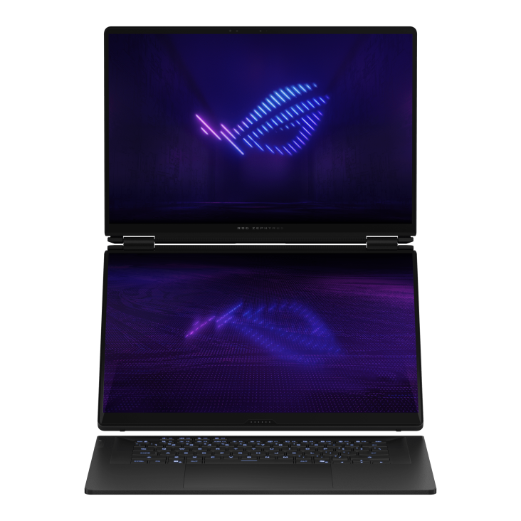  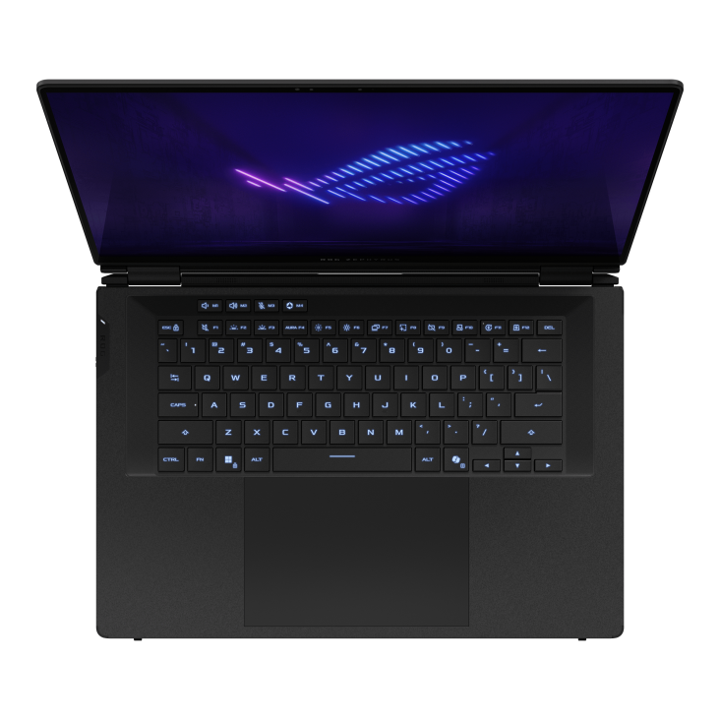
Processor | Intel® Core™ Ultra 9 Processor 386H 2.1 GHz (18MB Cache, up to 4.9 GHz, 16 cores, 16 Threads); Intel® NPU up to 50TOPS
Graphics | NVIDIA® GeForce RTX™ 5090 Laptop GPU  24GB GDDR7
Memory | 64GB LPDDR5X 8533 on board(Actual memory speeds may vary by CPU configuration.)  Max Capacity: 64GB  Support dual channel memory technology  Memory Slot: No expansion possible
Storage | 2TB PCIe® 5.0 NVMe™ M.2 Performance SSD | 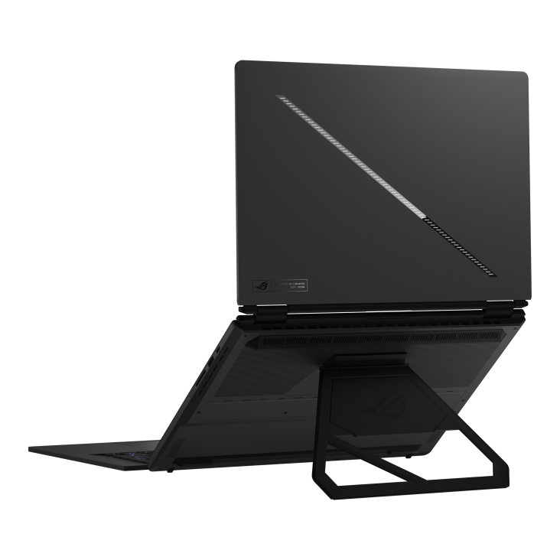
Display | ROG Nebula HDR Display  16-inch  3K (2880 x 1800) OLED 16:10 aspect ratio  OLED  Anti-glare(AG) display  DCI-P3:  100%  Touch Screen  Refresh Rate:  120Hz  Response Time:  0.2ms  G-Sync  Pantone Validated  Support stylus:  Yes  MUX Switch
Keyboard and Trackpad | Backlit Chiclet Keyboard 1-Zone RGB
Size and Weight | Weight: 2.82 Kg (6.22 lbs)  Dimension: 35.5 x 24.7 x 1.99 ~ 2.49 cm (13.98" x 9.72" x 0.78" ~ 0.98")

